**TMA 01: Design and construct a logic circuit which will operate as a full adder.**

Introduction:  
  
Digital computers and calculators perform various arithmetic operations on numbers that are represented in binary form. These operations are all performed in the arithmetic logic unit of a computer. Logic gates and flip-flops are combined in the arithmetic logic unit so that they can add,

subtract, multiply and divide numbers. These circuits perform arithmetic operations at speeds that are not humanly possible. We shall now study the addition operation circuit which is an important arithmetic operation in digital systems.

The Full Adder:

Computer performs the addition operation on two binary number at a time, where each binary number can have several binary digits. The addition process starts by adding the least significant bits (LSBS) of the two numbers. For Example:

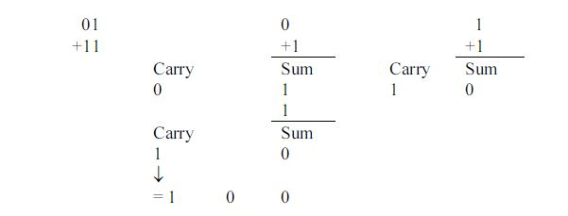

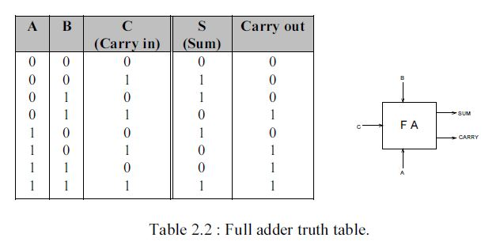At each step in this addition process we are performing the addition of 3 bits : two bits from two numbers and a CARRY in bit from previous position. The result of the addition of these 3 bits produces 2 bits : a SUM bit and a CARRY out bit. This CARRY would be added to the next bit position. The same process is followed for each bit position. Now we know the function of the full adder. So we can proceed to design a logic circuit that will perform this function. First we shall construct a truth table for such a circuit. Here, the SUM and CARRY outputs result from the addition of inputs A, B and the CARRY IN.

There are eight possible cases for three inputs and for each case the desired output values are listed. For example, consider the case A = 1, B = 0 and C = 1. The full adder (abbreviated FA) must add these bits to

produce a sum of 0 and a carry out of 1. Since there are two output, we will design the circuitry for each output individually, starting with the s output. The truth table 2.2 shows that A truth table for full adder.

there are four cases where s is to be a 1. Using the sum-of products method, we can write for the expression as,



We shall now try to simplify this expression by factoring. Unfortunately, none of the terms in the expression has two variable in common with any of the other terms. However, A can be factored from the first two terms and A can be factored from the last two terms :

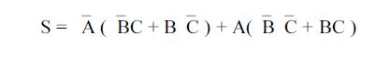

The first term in parentheses should be recognized as the exclusive OR combination of B and C This can be written as B C. The second term in the parenthesis should be recognized as the exclusive NOR of B and C. Thus the expression for S becomes.



Let us take X = B C. Then above equation can be written as,

S =A X + AX = A X

Which is simply the Ex-OR of A and X. Replacing the expression for X, we have



Consider now the output carry out in the truth table 2.2. We can write the sum-of -products expression for carry out as follows :

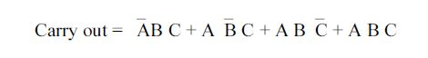

This expression can be simplified by factoring. We will employ a trick by using ABC term three times in this expression. This is, because it has common factors with each of the other terms. Hence,

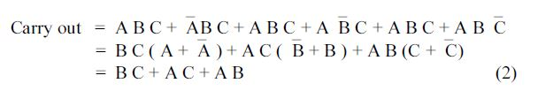

This expression cannot be simplified further. Expressions (1) and (2) can be implemented as shown in Fig. 2.3. The complete circuit with inputs A, B and C and outputs S and carry out represents the full adder.

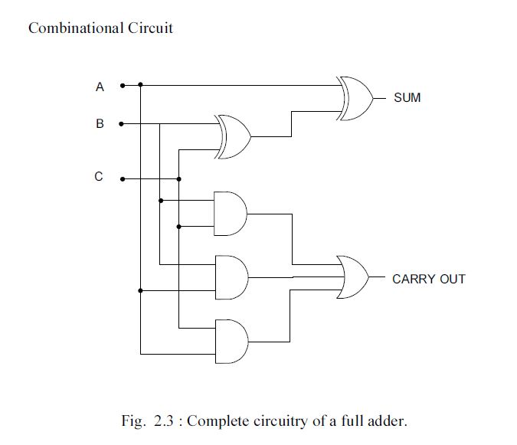

A full adder circuit can be constructed using two half adders. Two of the three inputs are connected to the first half adder which produces a partial sum and partial carry output. The partial sum is fed to the second half adder along with the third of the original inputs. This causes the final sum to be produced and also another partial carry.

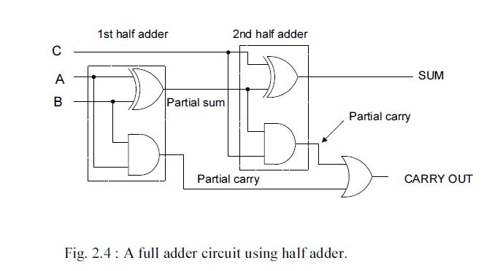

This partial carry combines with the other partial carry and gives the final carry output. The three inputs to such a full adder, A,B and C are completely interchangeable.

**TMA 02: How many types of sequential logic circuits? Describe briefly.**

Introduction:  
  
A combinational circuits implements the essential functions of a digital computer. "A circuit known as

combinational as long as its steady state outputs depend only on its current inputs". In these circuits, there is no ability to retain the information regarding the state of the circuit and any prior input level

conditions have no effect on the present outputs because they provide no memory. So for the later purposes, sequential circuit is used. In sequential logic circuit, the present values of outputs are dependent on both present values of the inputs and the past values of inputs. A sequential logic circuit consist of two parts.

1. the memory elements i.e. flip-flop which is made up of an assembly of logic gates.
2. the combinational logic circuits needed to produce the excitation inputs to the memory elements and to produce the required outputs.

Sequential circuits find wide application in digital systems as counters, registers, control logic, memories and other complex functions.

Examples,

_ The elevator control.

_ The traffic light system.

_ automatic lock - which remember the combination of numbers and also their sequence.

Types of Sequential Logic Circuits:

Depending upon the timing of sequential circuit signal, the sequential logic circuits can be divided into two classes.

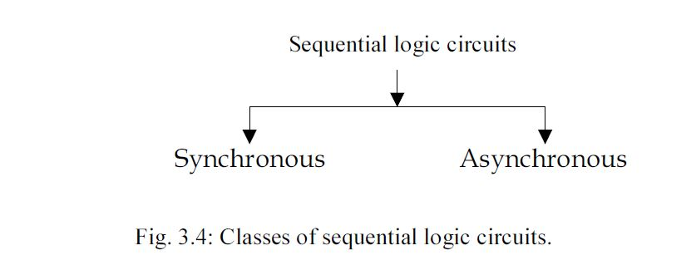

Synchronous Sequential Circuits A synchronous sequential circuits is one in which the contents of the memory can change only at discrete instants time or on the of transitions of a clock. Since all the circuit action will take place under the control of a clock, so these circuits are known as clocked sequential circuit.

Advantage

They are easier to troubleshoot and design because its outputs can change only at specific instants of time i.e. everything is synchronized to the clock signal transition.

Asynchronous Sequential Logic Circuits

An asynchronous sequential logic circuits is one whose outputs can change state at any instant of time with the change of one or more of the inputs. The memory elements used in these systems are delay type memory elements. It can be regarded as combinational circuit with feedback.

Disadvantage

It is difficult to design and troubleshoot and used only for simple configuration.

Flip-flops (FF)

A FF is an electronic device that has two stable states. One state is assigned the logic 1 value and the other is the logic 0. In other words, the memory elements used in sequential circuits are the flip flop. These circuits are binary cells capable of storing one bit of information.

Latch

A latch is a bistable circuit that is the fundamental building block of a flip-flop. It exists in one of the two states (e.g. 1 and 0), and in the absence of the input, it remains in that state. It has two output y and _y.

The following Fig. 3.5 illustrate a simple FF or 1 bit memory (i.e. it can store one bit of information y = 0 or y = 1) and since this information is locked or latched so, this FF is known as a latch.

